# Introductory Piano – Key of C

Currell Berry

Piano is all about patterns and teaching your fingers! Don’t forget to have fun.

**Musical Notes:** 12 Notes **--** A A# B C C# D D# E F F# G G#

**Major Scale Steps:** Whole Whole Half, Whole Whole Whole Half.

C major scale is the easiest, you just play all the white notes.

Learn to identify the notes.

**Notes on the Keyboard:**

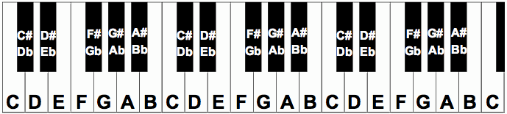

The “root” of a chord is the primary note in the chord. The root of a “C” chord, for example, is C.

**Two Types of Chords:**

Major: start at root, count up 4, then count up 3.

Minor: start at root, count up 3, then count up 4.

**Most Important Chords in C:**

|  |  |
| --- | --- |
| C | G |
| C:\Users\vancan1ty\Desktop\c_piano_chord.png | C:\Users\vancan1ty\Desktop\am_piano_chord.png |
| Em | F |
| C:\Users\vancan1ty\Desktop\f_piano_chord.png | C:\Users\vancan1ty\Desktop\f_piano_chord.png |

Almost every song can be played fairly well as a combination of these chords!

Usually people don’t play the B diminished chord. It’s kind of weird.

**All Chords in the Key of C:**

**I II III IV V VI VII**

C Dm Em F G Am Bdim

# Easy Songs!

|  |  |
| --- | --- |
| Amazing Grace | Open the Eyes of My Heart |
| C F C  Amazing Grace, how sweet the sound,  G  That saved a wretch like me.  C F C  I once was lost, but now im found,  G C  Was blind, but now I see.  C F C  ’Twas grace that thought my heart to fear,  G  and grace my fears relieved.  C F C  How precious did that grace appear  G C  The hour I first believed.    C F C  When we've been there ten thousand years,  C G  bright shining as the sun,  C F C  We've no less days to sing god's praise  C G C  than when did when we first begun.  C F C  Amazing Grace, how sweet the sound,  G  That saved a wretch like me.  C F C  I once was lost, but now im found,  G C  Was blind, but now I see. | **C**  **Open the eyes of my heart, lord**  **G**  **Open the eyes of my heart**  **F C**  **I want to see You, I want to see You. (repeat whole thing once)**  **G Am**  **To see You high and lifted up**  **F G**  **Shining in the light of your glory**  **Am**  **Pour out your power and love**  **F G**  **As we sing holy, holy, holy.**  **C**  **Holy, holy, holy**  **G**  **Holy, holy, holy**  **F G**  **Holy, holy, holy**  **C**  **I want to see You.** |